i) A perfect binary tree of height 5, how many nodes are there in the left subtree of the root? (Height of a root node without childs is 0) [1 Mark] a) 23 b) 7 c) 25 d) 31
Answer: d) 31
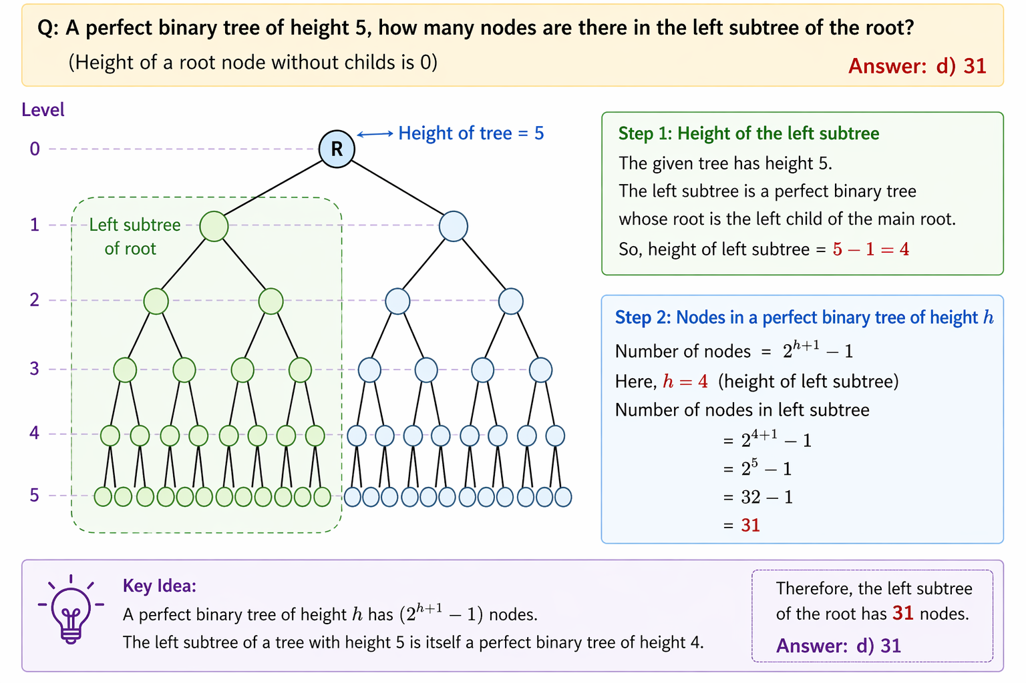

ii) In the sink/heapify operation of the remove function in a Max-Heap, with which child is the value of a node compared? [1 Mark]
a) Left child b) Right child c) The greater among its two children d) The minimum among its two children
Answer: c) The greater among its two children
Explanation : In a max-heap, to maintain the heap property, you compare with the larger child and swap if needed.
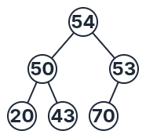
viii) You are given a Max-heap tree, but due to memory corruption, a node is violating the max-heap property.

Using the concepts of Swim() or Sink() (to move a value up or down the heap), update the tree so that it becomes a valid max-heap again .
Note: You are not allowed to remove any elements from the tree. No need to write any codes.
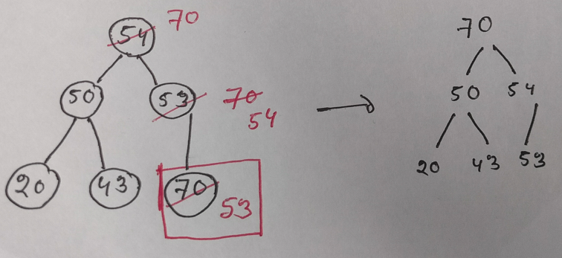(vi)
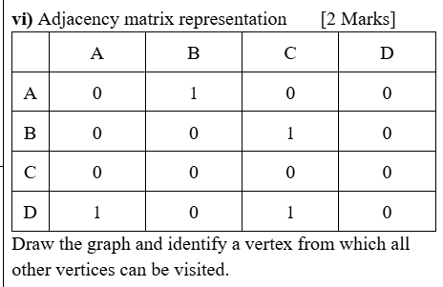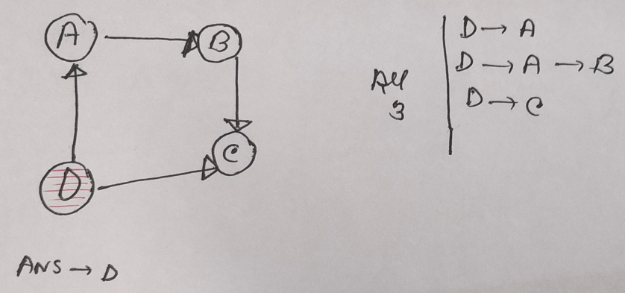

iii) What is the maximum number of edges in a directed graph with 6 vertices (no self-loops)? [1 Mark] [Medium]
a) 15 b) 36 c) 30 d) 12
Answer: c) 30
Explanation :
- Total vertices: n = 6
- From each vertex, you can connect to (n − 1) = 5 other vertices
- So, total edges: Max edges=n(n−1)=6×5=3

iv) A directed graph is represented using an adjacency list. If the total number of nodes in full adjacency lists is 15, how many edges are present? [1 Mark] [Medium]
a) 5 b) 10 c) 15 d) Cannot be determined
Answer: c) 15
Explanation : In a directed graph using an adjacency list:
- Each node’s list stores its outgoing edges
- So, total entries across all adjacency lists = total number of edges
Total nodes in all adjacency lists = 15

Why option (d): “Cannot be determined is wrong: (Most students answered)

It would only be correct if:

It were an undirected graph (because each edge appears twice), or

The representation was unclear

But here:

The graph is explicitly directed

The representation is clearly adjacency list
v) A binary tree represented using an array of size 72. Assume, all indices of the array have values except for 0 index. Is the node at index 37 a leaf node? a) Yes b) No
Answer: a) Yes
Explanation :
- Binary tree is stored in an array of size 72
- Index 0 is unused
- So valid indices are: 1 to 71
__________________________________________
For index 37:
- Left child index = 2i= 2×37=74
- Right child index =2i + 1= 2×37+1=75
But:
- The maximum valid index is 71
- Indices 74 and 75 do not exist in the array
So, node 37 has no left or right child. It's a leaf node.
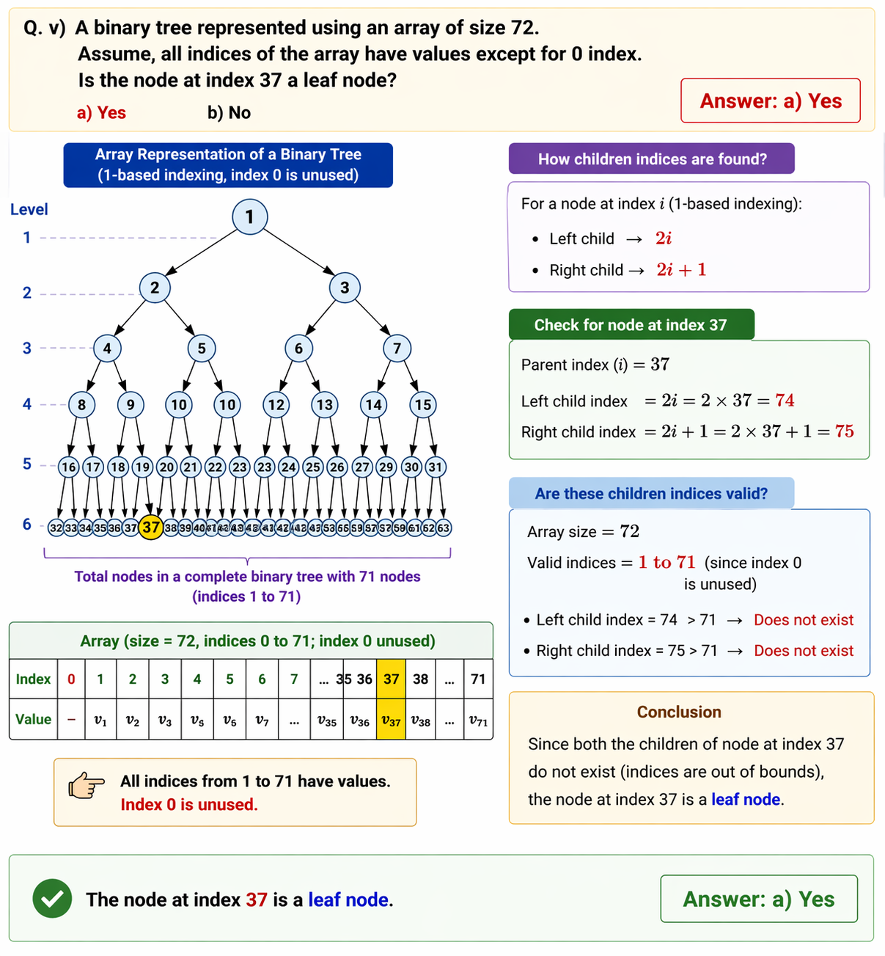

__________________________________________________________________________________________
vii) Which of the following tasks cannot be performed on a singly linked list in O(1) space and O(n) time complexity? [1 Mark] [Difficult]
a) Finding the k-th node from the end of the list
b) Finding the middle node of the list
c) Detecting whether the list contains a cycle
d) Checking whether the list is a palindrome
Answer: d) Checking whether the list is a palindrome
Explanation :
a) Finding the k-th node from the end → Possible
- Use two-pointer technique (one ahead by k nodes)
- Time: O(n), Space: O(1)
b) Finding the middle node → Possible
- Use slow and fast pointers
- Time: O(n), Space: O(1)
c) Detecting a cycle → Possible
- Use Floyd’s Cycle Detection (Tortoise & Hare)
- Time: O(n), Space: O(1)

d) Checking if palindrome → Not possible (without modification)
- Requires reversing second half or using stack
- Reversing modifies the list OR stack uses O(n) space
- So, cannot be done strictly in O(1) space without altering structure

